**LAB-WORK 11**

**1.Write a C++ program uing a Constructor.**

**CODE:**

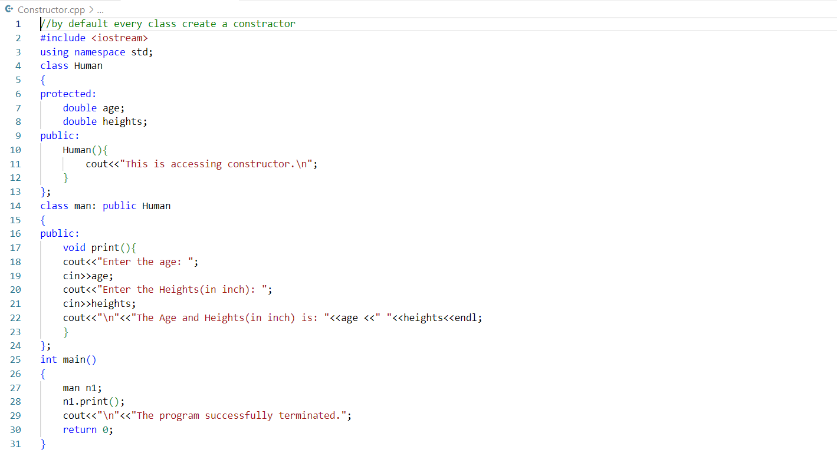

**OUTPUT:**

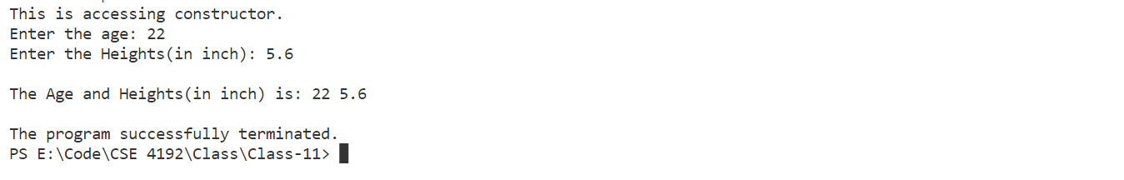

**02.Write a C++ program using Destructor.**

**CODE:**

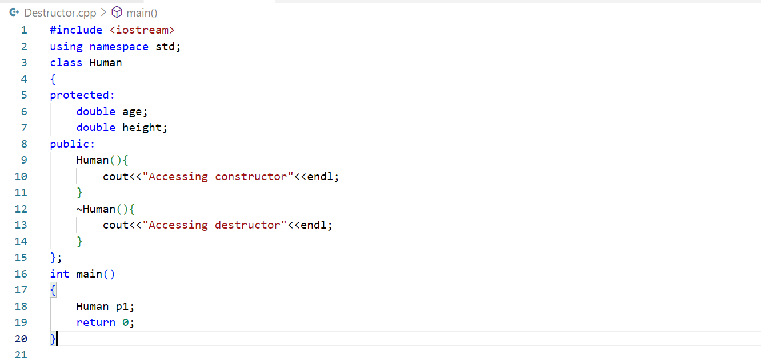

**OUTPUT:**



**03.Write a C++ Program using Copy Constructor.**

**CODE:**

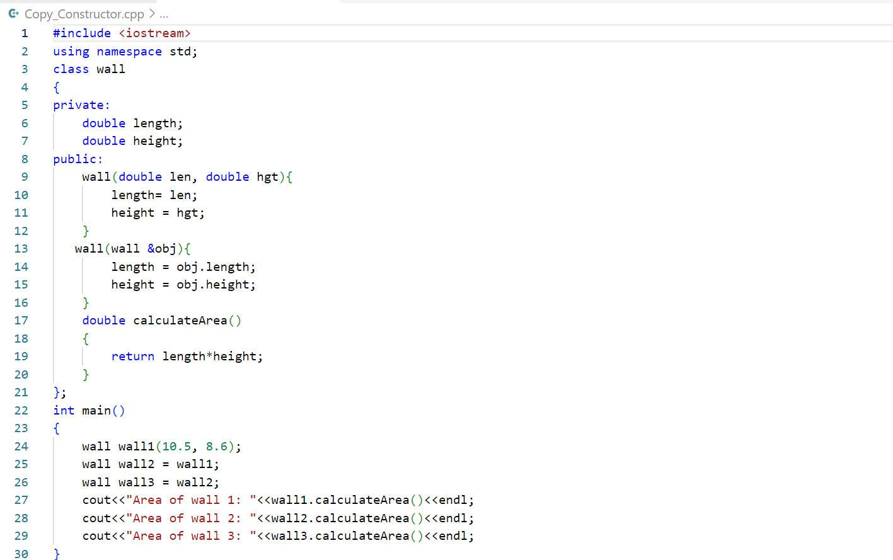

**OUTPUT:**



**04.Write a C++ program using polymorphism (overloading).**

**CODE:**

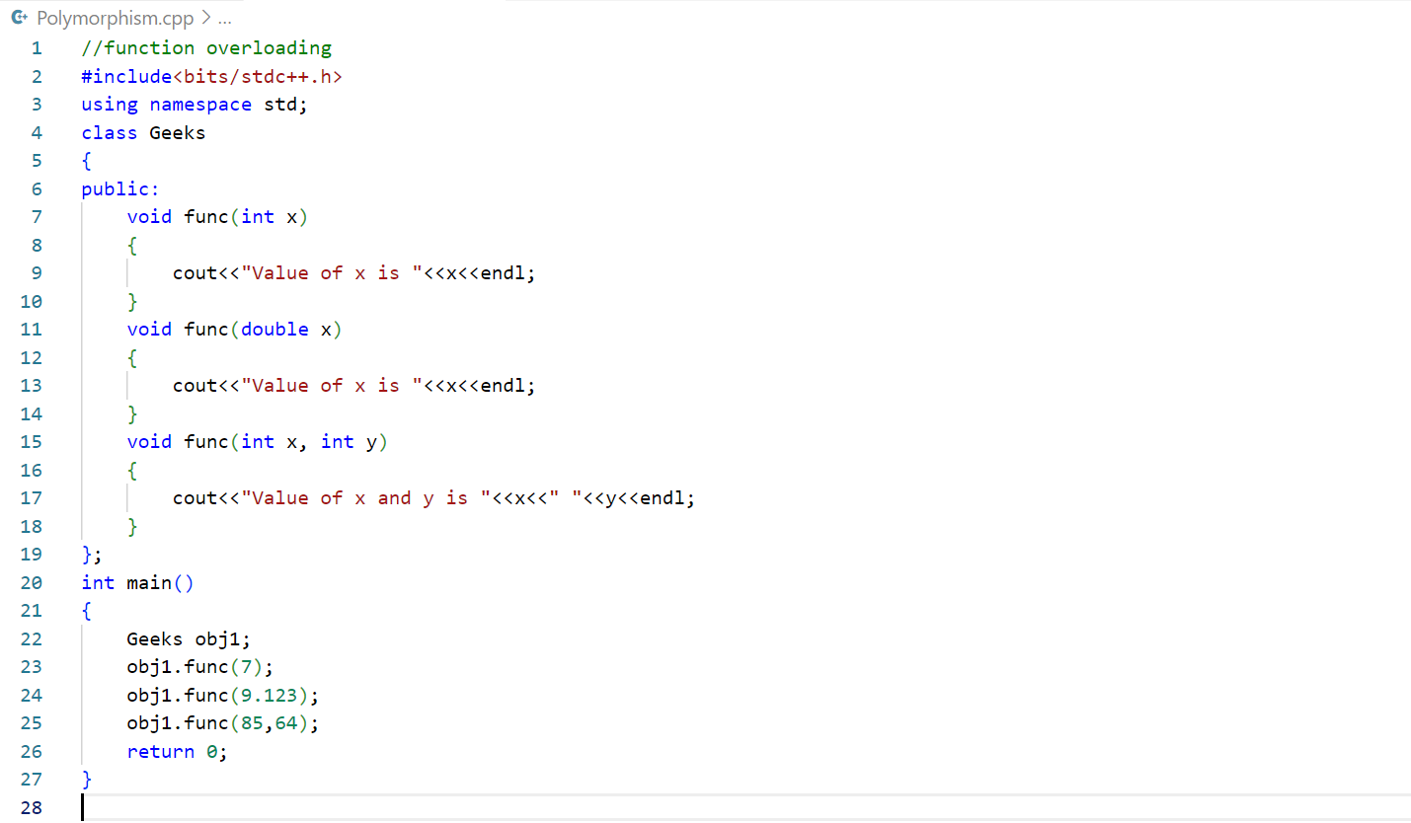

**OUTPUT:**



**05.Write a C++ program using run time polymorphism.**

**CODE:**

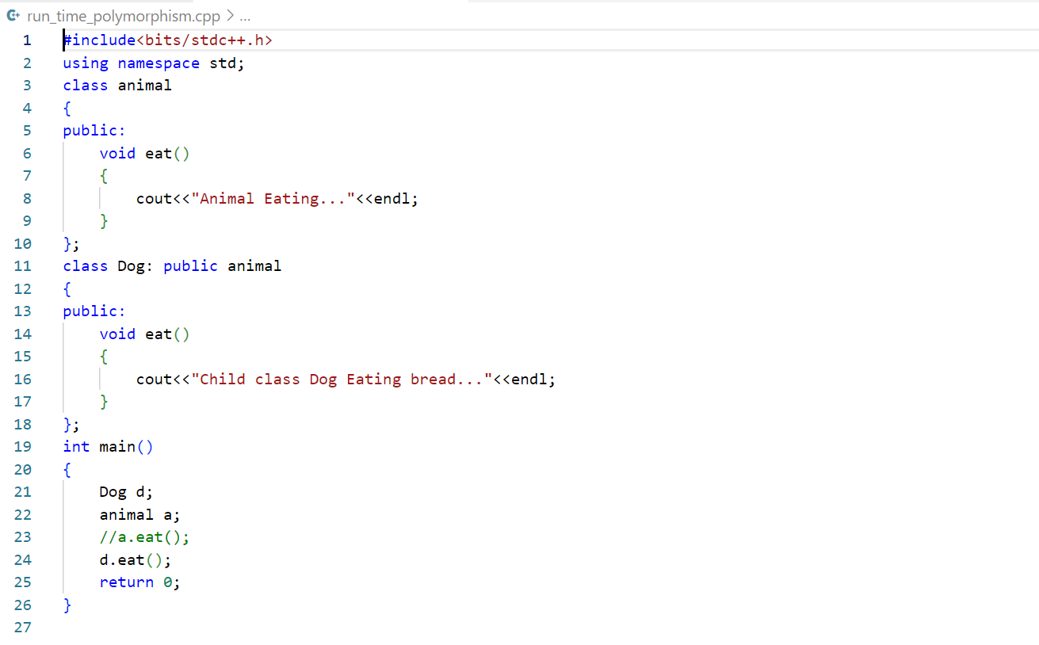

**OUTPUT:**

